**Exercise**

The purpose of this exercise is:

* To investigate **the cause of offset** in a P-only controller
* To investigate **the cause of** **oscillations** in a PI controller

## Open Loop Response

First Order Plus Dead time (FOPDT) model:

Where:

* Kp = 2
* τp = 200
* θp = 0
* Simulate the behavior for making a step change in manual mode from 0 to 10 (and back). Explain what happens in terms of oscillations or a smooth response.

**Solution**

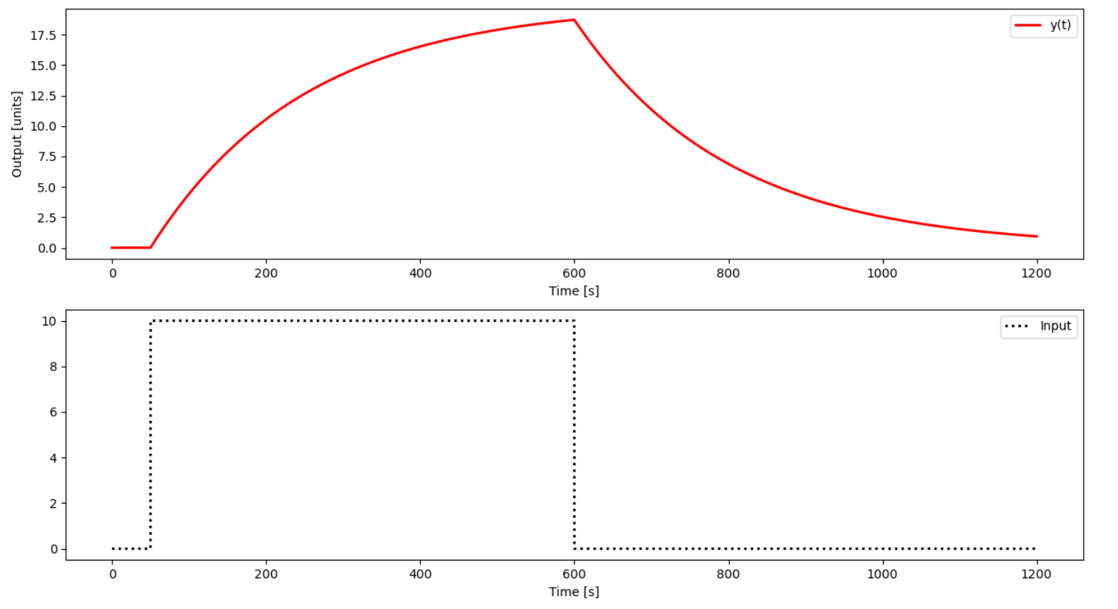

There are no oscillations, the response is smooth.

## P-only control

Simulate the behavior for using a P-only controller with:

* Kc=2
* Kc=0.5

Implement a set point change from 0 to 10 and back in automatic mode (closed-loop). Include a plot of the error between the set point (SP) and process variable (PV). What happens with increased Kc in terms of offset and oscillation?

**Solution**

**Kc = 2**

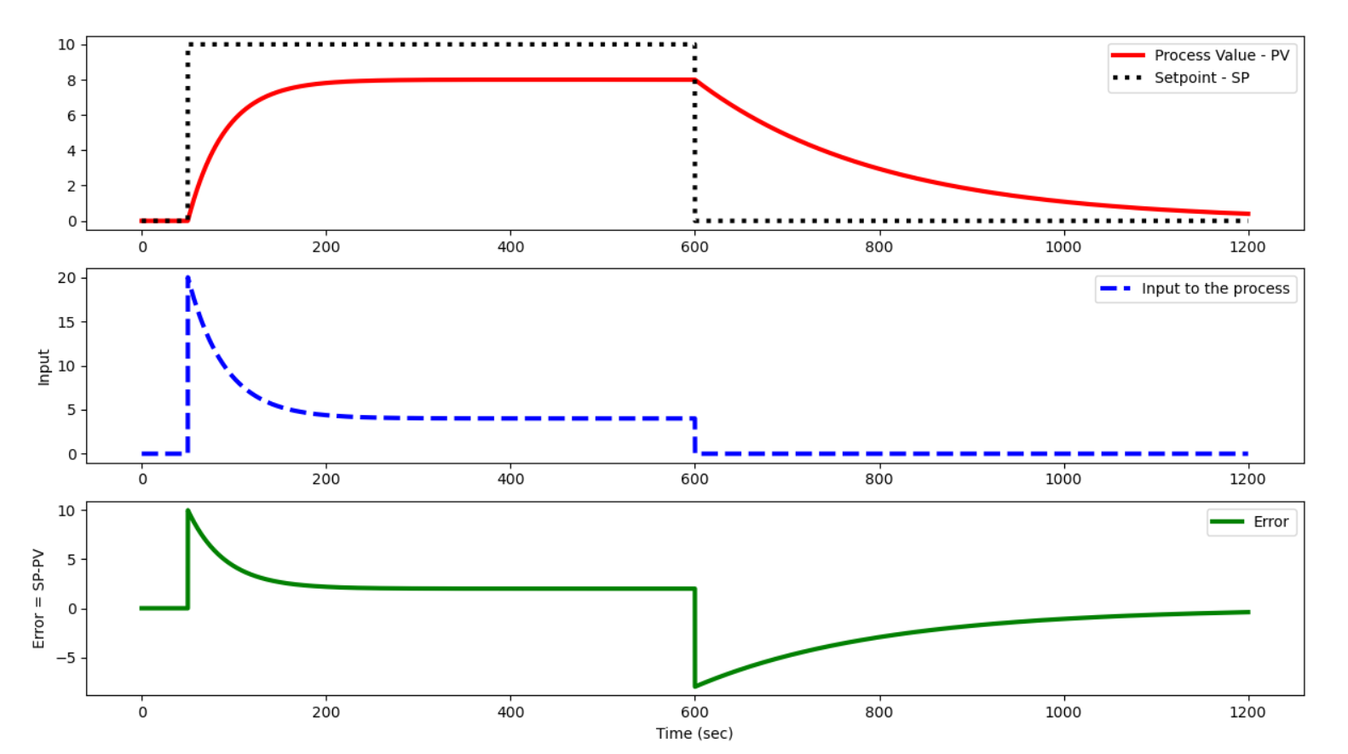

**Kc = 0.5**

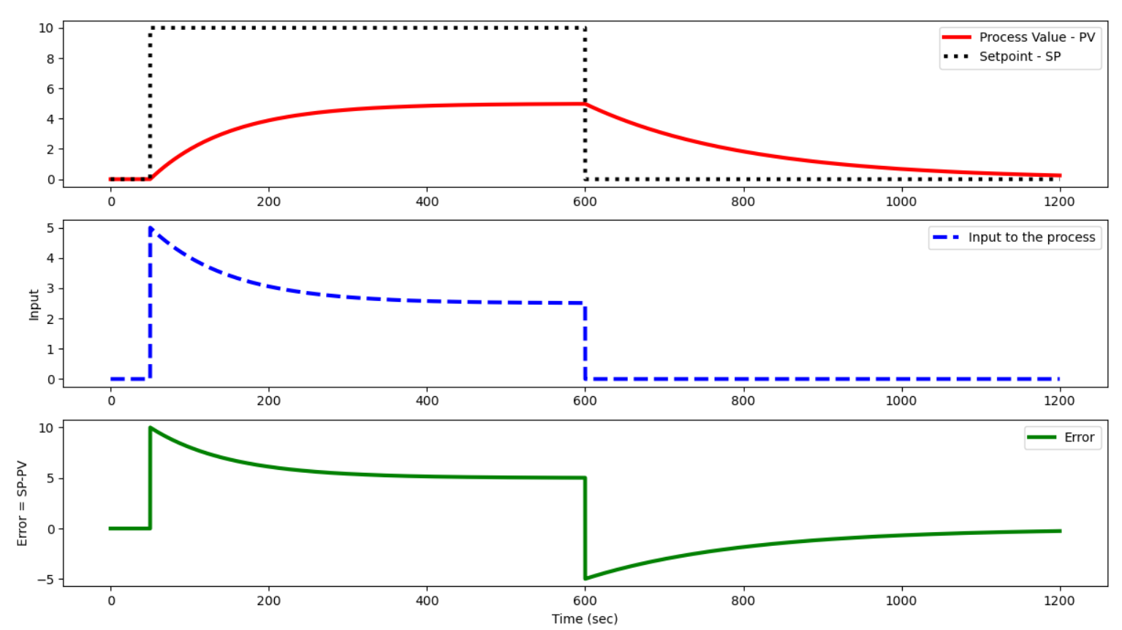

With an increased Kc, the offset is smaller and the final values is reached sooner.

## PI control

Configure the controller to add an integral term in addition to the proportional control with:

* Kc = 2

Simulate the PI controller response with integral reset times:

* τI = 200, 100, 10

Include a plot of the integral of the error between the set point (*SP*) and process variable (*PV*) with anti-reset windup. Explain what happens and why.

**Solution**

* Smaller values for the controller's integral time constant produce an increased oscillatory behavior on the output.
* The anti-reset windup prevents and increasing error accumulation when an upper or lower saturation occurs.

**τI = 200**

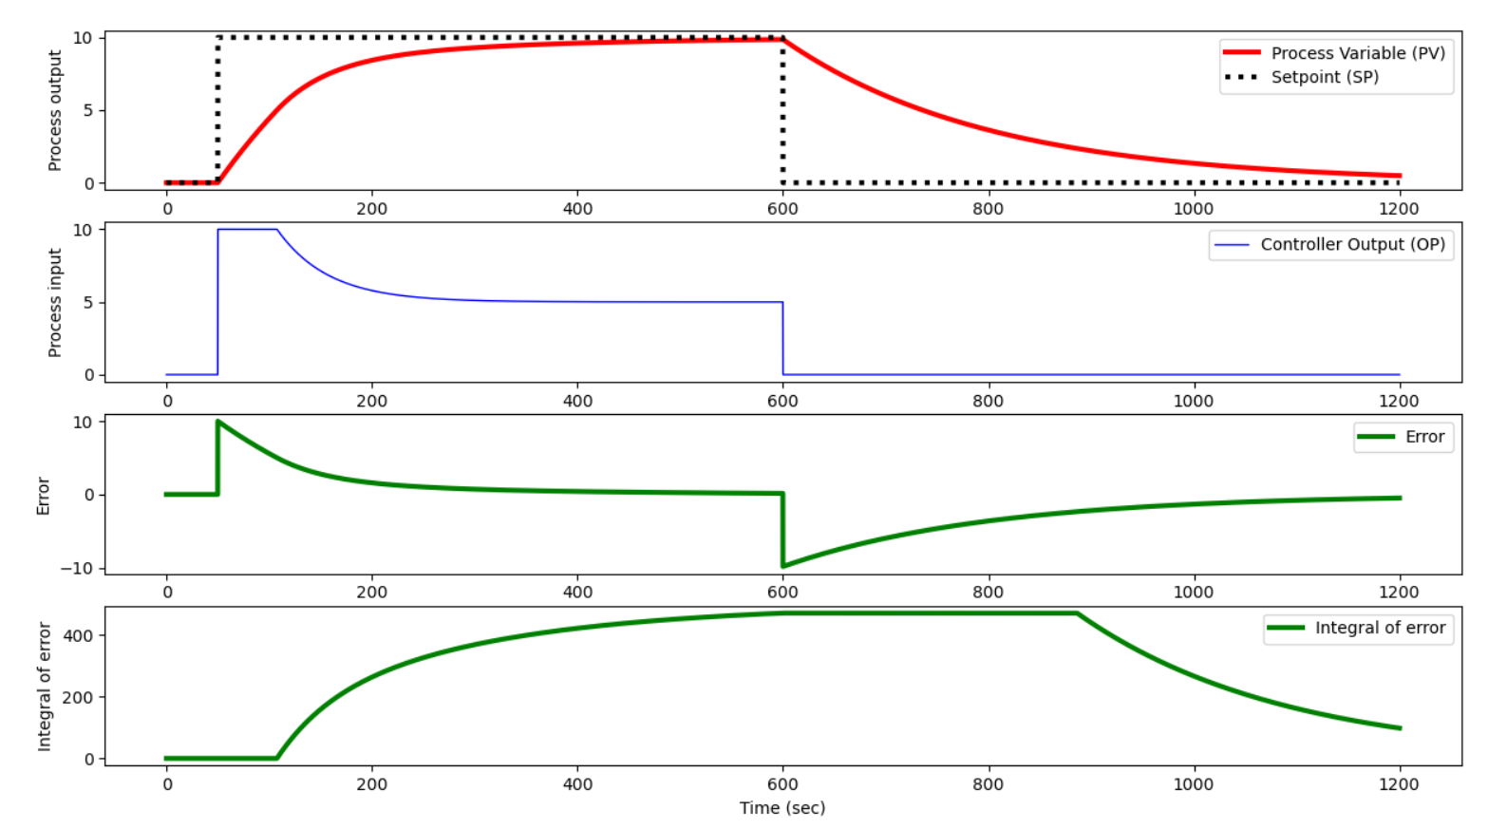

**τI = 100**

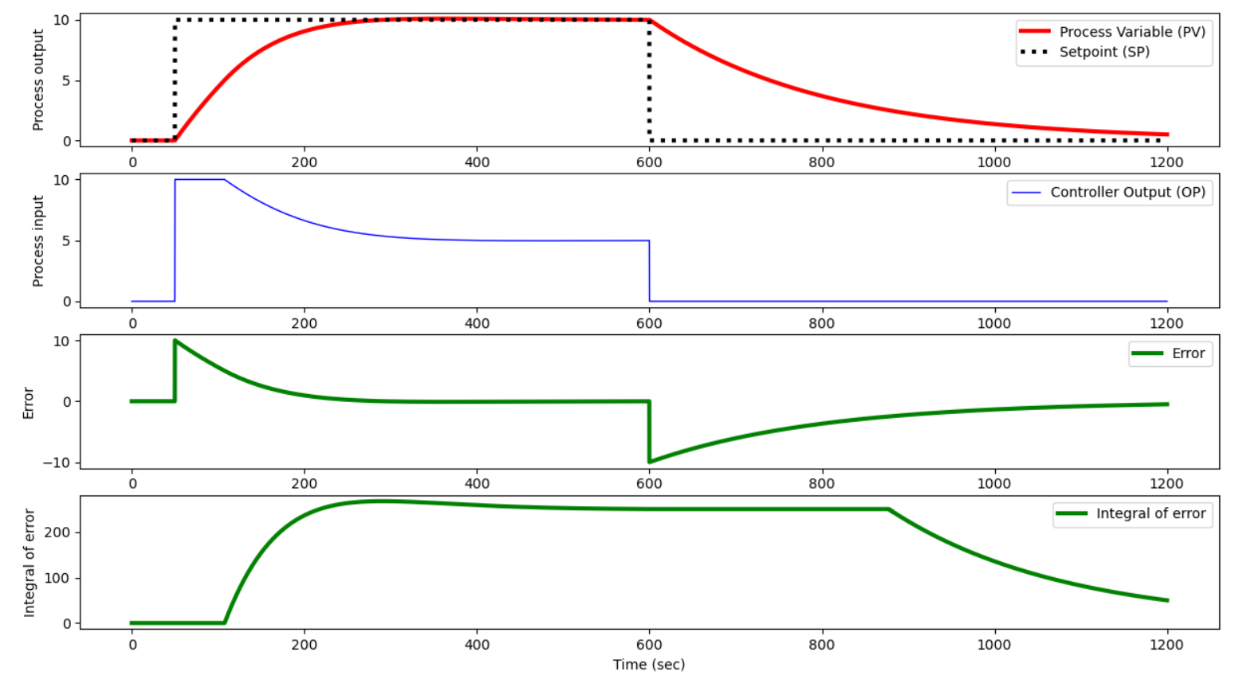

**τI = 10**

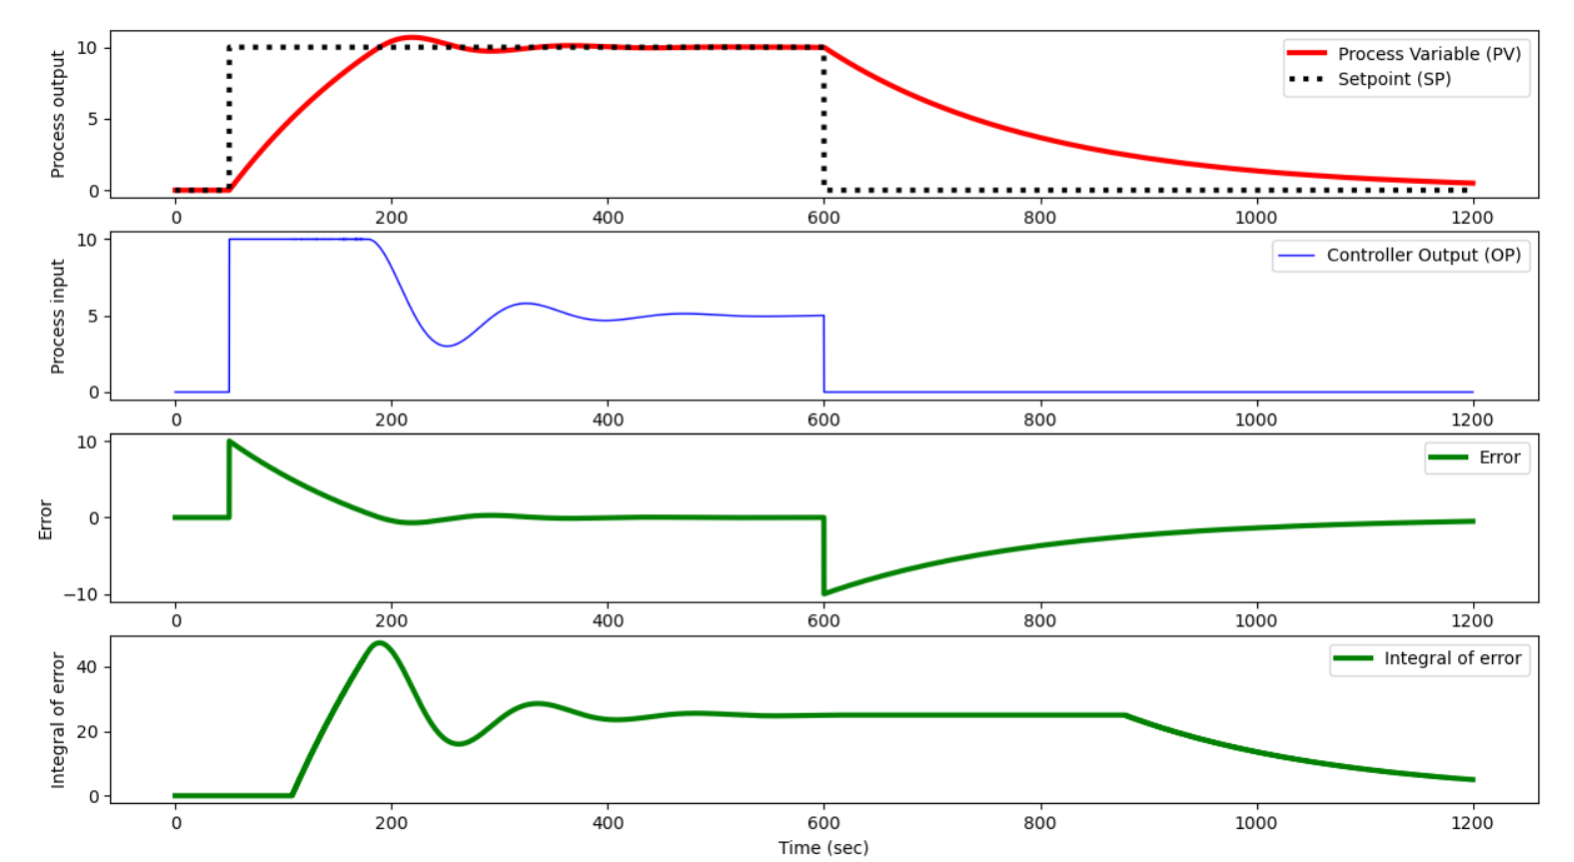

**τI = 10 and no anti-windup:**

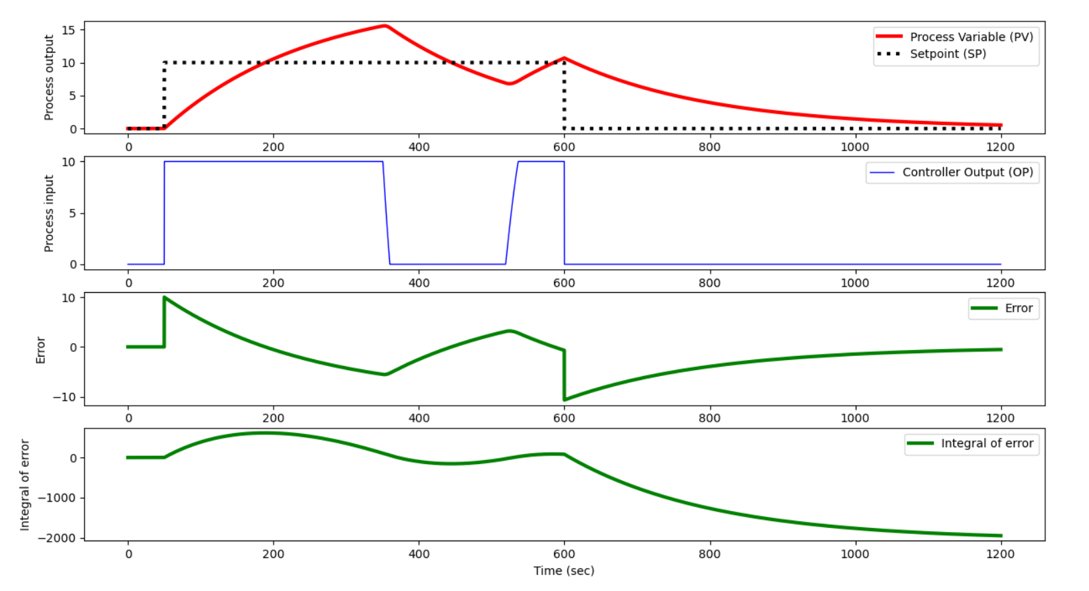

## ****Open Loop Response with Dead Time****

Add dead time θp=100 as an input delay. Simulate the behavior for making a step change in manual mode from 0 to 10 (and back). Explain what happens in terms of oscillations.

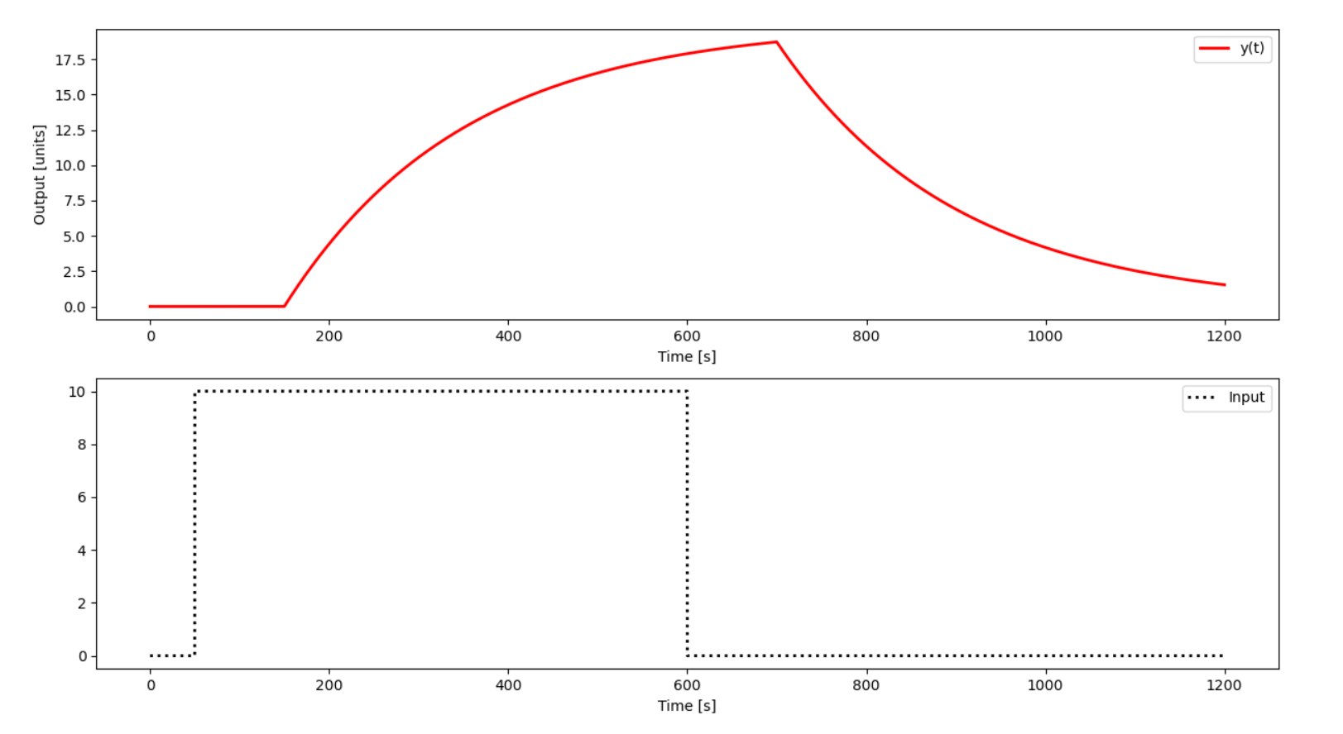

I see no oscillations in the open loop response, only the expected lag.

## P-only Control with Dead Time

With the dead time, simulate the response of a P-only controller with:

* Kc=2
* Kc=0.5

Implement a set point change from 0 to 10 and back in automatic mode (closed-loop). Include a plot of the error between the set point (SP) and process variable (PV). What happens with increased Kc in terms of offset and oscillation?

**Solution**

With Kc = 2:

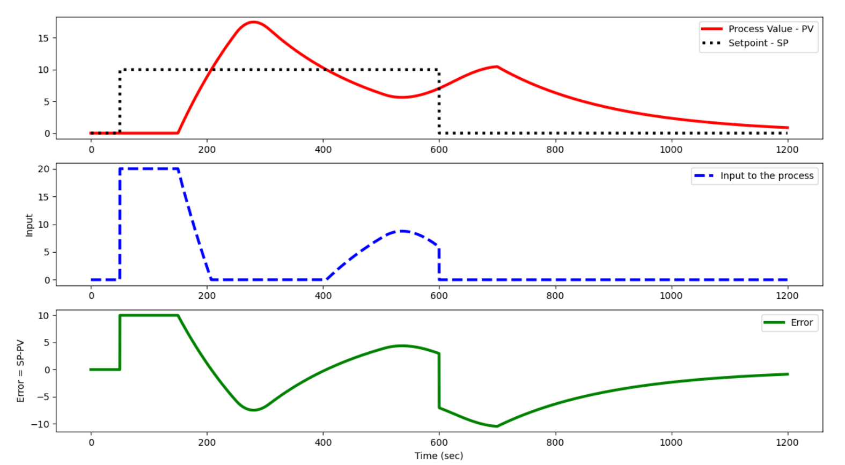

With Kc = 0.5:

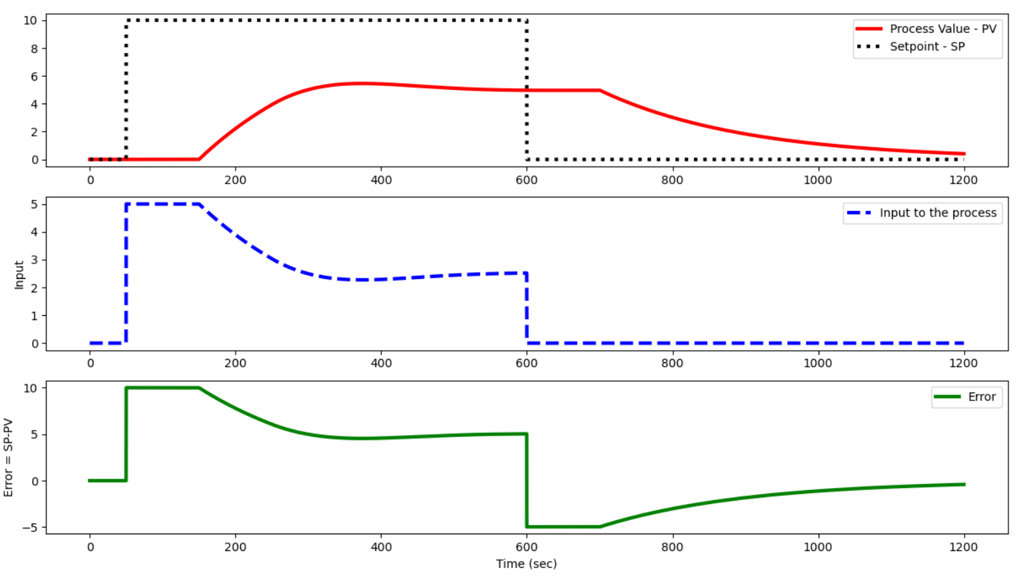

With an increased Kc, the offset diminishes but the oscillations increase.

## PI Control with Dead Time

Simulate the response of a PI controller with τI=200. Include a plot of the integral of the error between the set point (SP) and process variable (PV) with anti-reset windup. Explain what happens and why. Explain the results.

**Solution**

With, Kp = 2, τp = 200, θp = 100 and Kc = 2, τI = 200:

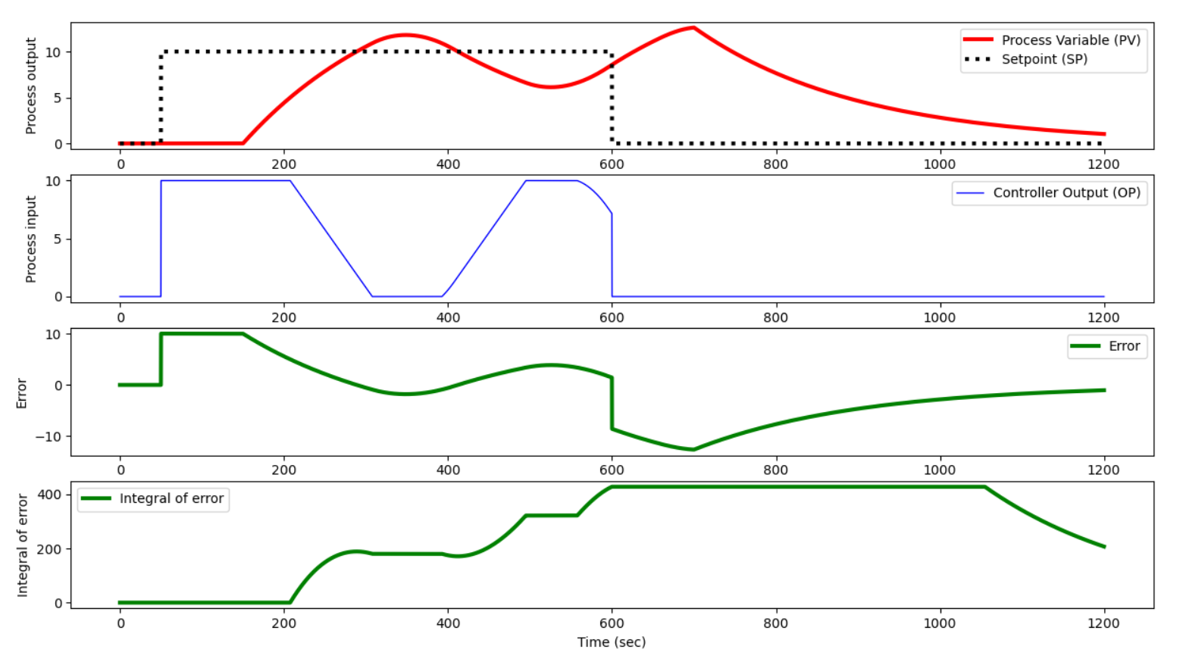

Having a dead time really complicates matters as it adds oscillations. When there was no dead -time and a PI control was used, the response converged without oscillations.

## Summary Questions

1. Based on the observations in manual mode, is the process stable or unstable?
2. Why does P-only control have persistent offset?
3. What is the effect of dead time on P-only and PI control?
4. If the process is stable, why can the control system make it unstable?

**Solution**

1. The problem seems to be stable as the output is bounded.
2. P-only control has persistent offset only when the process is non-integrative.
3. Dead time produces oscillations when in closed-loop.
4. I don’t know.